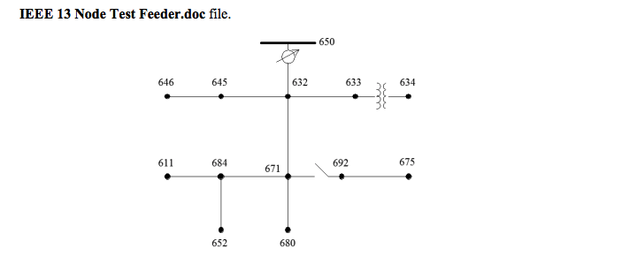 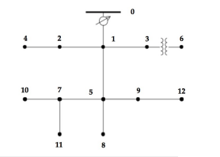

(re-labeling)

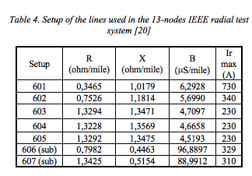

|  |  |  |  |
| --- | --- | --- | --- |
| sendingNodes | receivingNodes | lineLengths (feet) | lineConfigs (ohm/mile) |
| 632 | 645 | 500 | 603 |
| 632 | 633 | 500 | 602 |
| 633 | 634 | 0 | Transformer |
| 645 | 646 | 300 | 603 |
| 650 | 632 | 2000 | 601 |
| 684 | 652 | 800 | 607 |
| 632 | 671 | 2000 | 601 |
| 671 | 684 | 300 | 604 |
| 671 | 680 | 1000 | 601 |
| 671 | 692 | 0 | Breaker |
| 684 | 611 | 300 | 605 |
| 692 | 675 | 500 | 606 |

Line R and X:

Length (feet) * 0.0003048(feet🡪km) * (ohm/mile) / 1.609344(mile/km)

% spot load data

s_611= [0; 0; 170+80i]; % spot load at node 611 and the units in kW and KVAR. Y-I

s_634= [160+110i; 120+90i; 120+90i]; % Y-PQ

s_645= [0; 170+125i; 0]; % Y-PQ

s_646= [0; 230+132i; 0]; % D-Z

s_652= [128+86i; 0; 0]; % Y-Z

s_671= [385+220i; 385+220i; 385+220i]; % D-PQ

s_675= [485+190i; 68+60i; 290+112i]; % Y-PQ

s_692= [0; 0; 170+151i]; % D-I

% distributed load data (kW+kVAR)

d_632= [17+10i; 66+38i; 117+68i]/2; % Y-PQ

d_671= [17+10i; 66+38i; 117+68i]/2; % Y-PQ